

CONCEPTUAL DESIGN REPORT

Design Studio #4

Instructor: Gülbin DURAL

Members:

* Fatih ÇALIŞ
* Fatih ÇAM
* Recep GÜNAY
* Huzeyfe HİNTOĞLU
* Sarah ILYAS

Table of Contents

Title Page Number

Executive Summary of the Project

Introduction

Company Organization

Requirement Analysis

Standards for the Project

Solution Procedure

Expected Deliverables

Conclusion

# **Executive Summary**

Automata Technologies is a company formed by 5 passionate and intelligent engineers who are proficient in their respective areas. It was founded with only one purpose: to seek what is in the future and always innovate. We have been encountering more and more with projects integrating robotics and sports every day. However, we have never seen a project implementing hockey game with robots and we have seen a very big opportunity there. We, as Automata Technologies, are inspired by these developments and have started a new project which will create new possibilities for the future of sports industry.

We will design a robot which will play hockey with a similar robot on a standard hexagonal play field. The robots are to be teleoperated by players from up to 30 meters distance via transmitted images. **The specifications of the ball, play field, masking tape and robots will be decided in standard committee meetings**. Although the game sounds simple to play, the design and implementation of the project requires the integration of low latency video transmission and control commands, strong but low power shooting mechanism, smart defense and attack tactics and low cost but effective design choices. However, as Automata Technologies with our intelligent and passionate engineer team, we can overcome all these issues and complete the overall project with success in time by applying efficient and effective labor division, teamwork and integration of the individual knowledge among the company.

The problems to be solved are specified as follows: transmission of the first person video of the robot, transmission and executing commands, mechanical implementation of the robot and obstacle avoidance. We have proposed several solution methods to each problem and will research on the implementation of these solutions considering budget, feasibility and robustness.

* The main solution plan for the video transmission is using FPV transmission system which consists of a camera with NTSC output, a powerful video transmitter and a diversity type receiver combined with a display screen.
* The main solution plan for the shooting mechanism is using a spring system which consists of a rough spring, a servo motor to compress it and a platform to shoot the ball.
* The main solution plan for the transmission and execution of commands is to use an RF transmitter and receiver module integrated with a microcontroller.
* The main solution plan for the control of the robot is to combine various sensors such as IMU, obstacle avoidance and line follower with a microcontroller.
* The main solution plan to drive the robot is to use two wheels connected to motors and one free wheel using differential drive.

This document is a proposal for the mentioned product and contains the design and implementation procedures of the project. With scheduled hard work, our product will be ready on time without exceeding the budget as proposed in this document.

# **Introduction**

# **Solution Procedure**

The robot in this project is a tele-operated robot that tries to score by pushing or hitting a ball into the opponent’s goal, directly or indirectly. The operator remotely controls the robot (from a distance up to at least 30 meters) without actually monitoring the play-field with naked eye; the only means of monitoring the field is by means of a camera mounted on board the robot. In order to have reasonable solutions for the problems, the system must be analyzed with dividing it into subsystems so that the overall system can meet all the requirements. The system is composed of five subsystems that are Transmission Subsystem, Mechanical Subsystem, Electromechanical Subsystem, Control Subsystem, and Sensor Subsystem. In this project, there is one more optional operation. The robot can have defense mode. In this mode, the robot actions autonomously. If we can find cheaper solutions for the tele-operated mode, then we can consider autonomous defense mode. In this case, one more subsystem which is Image Processing will be added.

**a. Transmission Subsystem**

As mentioned before, the operator will control the robot from a distance up to at least 30 meters. Therefore, the only way that the operator can monitor the field is by using a camera mounted on the robot. This requires live video stream with sufficient resolution and low latency for proper operation. The solution for live video stream is FPV camera set. A FPV camera set is composed of a camera, an analog video transmitter with antenna, and a receiver. Since, the FPV cameras work on analogue video, their resolution is measured in TV lines or TVL rather than pixels. There are some options for TVL such as 420, 480, 600, 800 and 1000. Latency is another factor, which highly depends on both the distance and the quality of the transmitted video. It is usually around 50ms, which is ideal for our project. The transmitter basically processes the image that is captured by the camera and encode this data into an analog signal with a high frequency. The most commonly used frequencies by FPV cameras are 900MHz, 1.2GHz, 2.4GHz and 5.8GHz. Considering the obstacles that will be put on the area, 5.8 GHz is convenient for our project to transmit live video. The receiver decodes the signal that is radiated by the transmitter and convert this data into a displayable format. After this conversion, a screen is used to convert the data into a video. The screen is a smartphone or an AV monitor.

For the video transmission purpose, our main plan is to use FPV transmitter, receiver and camera. One of the most important issue about the video transmission is the transmitter output power. The transmitter output should be powerful enough so that the video signal can penetrate through walls up to 30 meters. However, it should be at the minimum power specification so that it will not cause a lot interference when reflected from the walls, it will not be unnecessarily expensive, and it will not cause interference for the other teams that might be using a similar set-up. The transmitter also has many channels in the bandwidth to choose from in order to differentiate the video signal from signals of other teams. We have experimented and demonstrated that we have clear, continuous and low latency video transmission with a 2000mW transmitter. However, we have bought another video transmitter that have selectable output power options from 25mW to 600mW. We will experiment with this transmitter too and will decide on which transmitter to use according to the experiment results.

The video receiver is also a very important factor in the video transmission system. A good receiver has a high sensitivity of signal power. Furthermore, we have decided that we should use a diversity type receiver for the continuity of the transmission since a diversity type receiver has two receiver modules inside. The two receiver modules have separate antenna inputs and the outputs of the receivers are compared according to the received signal strength. The output of the receiver modules which has the greater strength is connected to the output of the overall circuit which feeds into the monitor. The operation principle of a diversity receiver is shown in Figure X. The receiver that we experimented with is of diversity type and we have proved that the system works fine with this receiver in the demonstration. However, the video output of this receiver is television signals such as NTSC or PAL meaning that we need an AV monitor to display the video which adds to the cost of the project. Therefore, we have bought another FPV receiver which also has dual antenna system giving an output that can be displayed on smartphones. The sensitivities of the receivers are very close so we are expecting successful experiment results in the future.

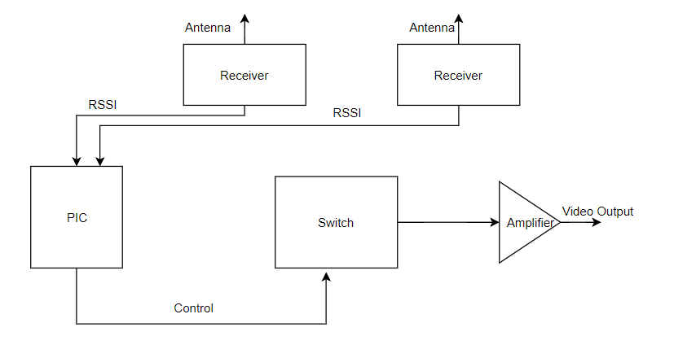

Figure X: The block diagram of a diversity receiver.

The other important parameter of the video transmission system is the antennae namely, the antenna of the transmitter and the antennae of the receiver. We are using circularly polarized antennae in the system since the polarization direction changes when a circularly polarized electromagnetic wave reflects from an object. The antennae on both the transmitter and receiver are of the same polarization direction that is right hand circularly polarized(RHCP) or left hand circularly polarized(LHCP) so that the wave portion that reflects from an object does not cause an interference since the antenna ignores a wave with another polarization direction. Furthermore, the antenna on the transmitter is of omni-directional type giving equal amount of gain in all directions since the robot will move in different directions and the wave will propagate from different directions. The advantage of using a diversity receiver comes out at this point since we have the capability of using two antennae on the receiver. We use one omnidirectional antenna and one directional antenna with a relatively high gain in order to have gain in all directions and a high gain in direction to increase the gain in that direction. The radiation patterns of an omni-directional antenna and a directional antenna are shown in Figure Y and in Figure Z, respectively. We have performed our experiments and the demonstration using all omni-directional antennae and the results were very promising. We have bought better antennae with higher gains and hopefully we will improve our range and video quality. We can also increase the range by pointing the receiver towards the robot at all times to ensure that the receiver uses the input of the directional antenna.

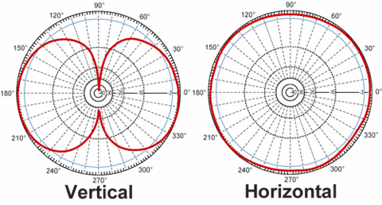

Figure Y: The radiation pattern of an omni-directional antenna.

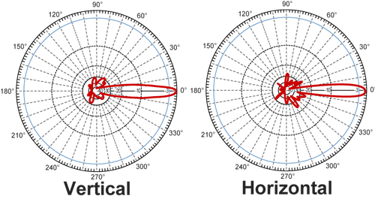

Figure Z: The radiation pattern of a directional antenna.

The camera used in the system is also very important since the quality of the displayed image depends on it. The camera we have experimented and demonstrated with is a high quality camera costing 25$. Although the demonstration was very successful since we had a high quality video on the monitor, we are prompted to experiment with other cameras out of budget and viewing angle considerations. We have bought a camera with wider angle of view and less costly to view more part of the field at one time to reduce the movement of the camera. If we have a camera with wide enough angle of view, we will not need to rotate the camera at all during the game. The monitor will be either an AV monitor or a smartphone according to the experiment results and budget considerations at a later time.

Aside from the main plan for the video transmission, we are considering two other methods to obtain directions to control the robot. One solution is only transmitting information about the direction and distance of the opponent, walls, the ball and goal and middle lines using image processing on board the robot. This solution will not suffer from any bandwidth problems in the video transmission but will probably suffer from latency. This is because image processing with a control card in our limited budget is a really slow process and the received information will also have to be converted into meaningful information to understand what is transmitted. The other solution method can be using GSM operators to upload the video on the internet and downloading it on the receiver side. This method can overcome any distance and obstruction issues since the video can be uploaded and downloaded anywhere at any time. The drawback of this method is due to budget since uploading and downloading the video and integrating a GSM operator with a controller are very expensive.

In summary, in the main plan for the video transmission, the FPV camera will capture image with enough resolution and frame speed. Then the transmitter will make process on the image and send it to the receiver in analog signal mode at high frequency, and the receiver will receive the video signal from the more powerful antenna of its two antennae and give the output to be displayed on the screen. Finally, the received image will be displayed on a screen.

**b. Mechanical Subsystem**

Mechanical subsystem consists of robot chassis and hitting mechanism. The chassis can be 2WD or 4WD. If we use 2WD chassis, then we will put one ball caster so that the robot can maneuver easily and reach the ball as soon as possible. If we use 4WD chassis, we are planning to use 360 degree rotating wheels. These wheels make the robot capable of moving directly in different directions. As the hitting mechanism, we are going to use a spring system. When the robot reaches the ball, it will take proper position and compress the spring. When it releases the spring, the mechanism will hit the ball with enough force and send it straightly.

**c. Electromechanical and Power Subsystem**

Electromechanical subsystem is composed of motors and motor driver. Basically, it is responsible for moving the robot. We are going to use DC Brushed motors and L298 motor driver (H- Bridge). These components are commonly used for this purpose and easy to use. For power supply, we will use LiPo battery. LiPo battery is the most convenient one because it has higher weight-energy rate, volume-energy rate, high voltage, and long lifespan. It also keeps for long because of the low self-discharging rate. Moreover, we are planning to put servo motor that is connected to camera the on the robot so that we can move the camera to have a better sight. This also plays very important role for the project because we have to have as better sight as possible to make proper movements with the robot in order to reach the ball and take action on time.

**d. Control Subsystem**

Control subsystem consists of two parts. One is remote control devices and the other one is microcontroller. For the remote control devices, we have two solution approaches. The first one is using 6-Ch RC Transmitter & Receiver. We are planning to use 4 channels for controlling the robot movements, 1 channel for adjusting the camera angel, and the last channel for shooting. This device quite practical and convenient for the project. It is in low power consumption for durable using. It also high receiving sensitivity. Despite all these advantages, it is quite costly when we consider budget limit. Therefore, we have another solution for remote control. The solution is building our own 7 channel RC transmitter and receiver using 2 NRF24L01 RF Transceiver IC and 2 Arduino NANO. The nRF24L01 is a highly integrated, ultra low power (ULP) 2Mbps RF transceiver IC for the 2.4GHz ISM (Industrial, Scientific and Medical) band. This frequency band is the same with the one in the first solution. It enables the implementation of advanced and robust wireless connectivity with low cost 3rd-party microcontrollers. The microcontroller will be Arduino NANO. This solution will decrease the cost for remote control part. Therefore, we will be able to allocate some budget for the optional autonomous mode of the robot. For the microcontroller that is embedded on the robot, we have again different solution approaches for different cases. If we use 6-Ch RC Transmitter & Receiver that is available on the market, we will be using Arduino NANO or Tiva TM4C123GXL. Arduino NANO is the simplest solution between them. It will get the signal(sent by RC transmitter) from the receiver and control the robot according to instructions. It can handle the requirements for controlling the robot. Tiva C Series controller is another option and can have better features. The most remarkable feature is the clock speed. It provides more speed and programing flexibility than Arduino NANO. The last option is Raspberry Pi. This option will be considered only if we can build our own 7-Ch Transmitter and Receiver. In this case, we will have autonomous mode for the robot and this requires image processing. Raspberry Pi is the suitable one for this purpose.

To sum up, control subsystem’s function is that Transmitter sends the signals to the receiver that is on the robot, then the receiver generates pulses and sends them to the microcontroller and finally microcontroller interprets these signals and generate commands for the robot. At the end, the robot moves according to the instruction that is sent by the operator.

**e. Sensor Subsystem**

Sensors are used to measure a property, such as pressure, distance, position, temperature, or acceleration, and respond with feedback. According to the feedback, the robot takes action to fulfill its duties. If we do not include autonomous mode for the project, then the only sensor we will be using is a color sensor. The color sensor product provides RGB (Red, Green, Blue) light sensors for precise color measurement, determination, and discrimination. We are going to use the color sensor to identify center-line and goal lines marked by “masking tape” because the robot is forbidden to pass on center-line and get behind the goal line. If we can handle budget issue and have autonomous mode, then we will include distance measurement sensor which is HCSR-04 and Inertial Measurement Unit which is MPU6050. HCSR-04 is the most well-known and available distance measurement sensor. This ultrasonic sensor has a 3mm sensitivity and 2-400cm range. It can be used in distance measuring, radar and robot applications. We are planning to use this sensor to measure distance between the robot and the walls so that the robot does not hit the wall. MPU-6050 is a six-axis IMU sensor card which includes a triaxial gyro, a triaxial angular accelerometer and often used in various robotic projects. It is very accurate, as it contains 16-bits analog to digital conversion hardware for each channel. Therefor it captures the x, y, and z channel at the same time. The sensor uses the I2C-bus to interface. The sensor will make measurements and then send the data to the controller. Using the feedback data that comes from IMU, the controller will stimulate the robot to take action and have proper position to defend ist goal and attack to score a goal.

# **Cost - Budget Analysis**

# **Time Table**

The time plan for the project is determined by estimating the duration for design, tests and implementation of the subsystems namely, transmission, mechanical, electromechanical & power, control and sensor subsystem. It is more appropriate to spare more time on the transmission and the control subsystem since both of them are considered as the most complex and crucial parts of the project.

The integration of the subsystems will probably lead to some mechanical, interference or wiring problems and therefore, we have spared the last month and a half on the troubleshooting. The ganchartt created for the project is given in Fig2.



Fig 2: The time table of the processes in the project

# **Conclusion**